Chemistry Unit 1 & 2 – Assignment #1
Analytical chemistry is the branch of chemistry that deals with analysing samples to identify whether or not compounds are present in a material and – if they are present – then in what concentration. This has a large range of applications in different contexts including forensics, mining, agriculture, medical and environmental science.
There are a range of instruments which can aid in identifying substances. In this task you will learn about the following analytical methods:
- Atomic absorption spectroscopy (AAS)
- Gas chromatography-mass spectrometry (GC-MS)

Components of this assignment:
- Part 1: Complete short answer worksheet about AAS and GC-MS. Completing this worksheet will help you learn about AAS and GC-MS. This worksheet will not be marked separately BUT you will receive a test about AAS and GC-MS to see how much you have learnt.

- Part 2: You will prepare a written assignment which focuses on applications of ONE method (either AAS or GC-MS). You will also need to submit your research notes. You will be marked on your scientific understanding of the method and your ability to write a research-based assignment. This components of the assignment is worth approximately 25% of the assessment mark.

- Part 3: In class, you will complete a validation test to ensure that you understand content related to AAS and GC-MS. The format of the test will be similar to other chemistry tests. It will be performed under test conditions and you will only have access to the chemistry data book. This component of the assignment is worth approximately 75% of the assessment mark.

Suggested preparation:
Before beginning the assignment you will need to learn about the various methods. Your first step should be to read the relevant sections of your textbook.
Topic | Page | Notes
Atomic absorption spectroscopy | 127-130
Mass spectrometry | 131-132
Chromatography | 289-297 | Focus on the introduction and the GC sections
Analysing elements | 9-15

Complete Part 1 of the assignment before starting Part 2. The information in Part 1 will give you a basic understanding of AAS and GC-MS.
For your extended response you need to write about a particular application of AAS or GC-MS (see suggestions on Page 2). If you are interested in writing about a particular application, you should look up information about how that sample is analysed with either AAS or GC-MS. Most applications are only analysed using one of these methods. Make sure that there is sufficient information available before deciding on a topic – some topics will be easier to write about than others.
It is also possible to write about applications other than the ones suggested. If looking for inspiration, try searching for terms such as ‘what is atomic absorption spectroscopy used for’ or ‘applications of GC-MS’. If you are unsure about whether a particular application is okay or not then check with your teacher first.
Part 2: Extended Written Response
For your extended answer you need to write a 2-3 page assignment explaining how either GC-MS or AAS is used for a particular application. You application could be chosen from the following list or could be another application of your own choice:
Applications of AAS | Applications of GC-MS
- Analysing mercury content in fish  - Analysing the lead content of paints  - Analysing the concentration of trace elements in soils  - Analysing the mineral content of ores  - Analysing presence of heavy metals in the environment | - Identifying banned drugs in urine samples  - Identifying contaminants such as pesticides in foods  - Identifying accelerants at the scene of a potential arson  - Detecting traces of chemical explosives  - Identifying poisons in toxicological samples

Information you need to include:
- Background information about the substance that needs to be analysed and why it is important that we can analyse/identify/detect these substances.

- Information about how that sample can be analysed using either GC-MS or AAS, including:
  - How the analytical method works (e.g. how GC-MS works or how AAS works)
  - How the collected data is used to analyse your sample (e.g. calibration curves / GC-MS spectra)

- See the marking key for full details of requirements
STAGE 1: Planning and Research

- Once you have decided on a topic you will need to research information about your chosen application. Use the provided research note-taking template. Use a separate page for each notes. Make sure you record the reference details for websites as you go (this will be very important when it comes time to write and reference your report).

STAGE 2: Organise your ideas

- Decide on the general structure of your report. What will be your sections and what are the main pieces of information that need to get placed in each section? There are more details about what is expected in a report structure on Page 3

STAGE 3: Draft your response
- Organise your information into paragraphs and include images. Use in-line referencing to show where each part of information has come from. (There is more information about in-line referencing on Pages 4-5.) You should constantly be checking the marking rubric during this process to ensure that you are including all that is needed.

STAGE 4: Proof-read and refine
- Re-check the marking key and make sure that you have addressed all the main criteria
- Proofread for spelling and grammar, and make sure that your writing ‘flows’ and is in logical order
- Check that all figures and tables have labels and are referred to in the text.
- Make sure that all information that you did not come up with yourself is referenced using in-text citations. This applies to both text and images.
Format of a written response:
Written chemistry assignments have some similarities with an English essays, but they also have clear differences. For example, a science assignment should have headings breaking up the assignment into different sections and where appropriate should include diagrams, graphs, chemical equations, calculations and tables.
Your response should include:
Section | Content
Introduction | - Describes the topic of the assignment  - Gives the minimum necessary background for the topic
Body – Various sections | - Uses section headings to break up content  - Discusses content in a clear and logical order  - Uses relevant examples and information to support ideas  - Uses figures (diagrams and graphs) and/or tables to support the text  - References all sources of information including figures and tables  - Numbers and labels all figures and tables
Conclusion | - Briefly restates purpose of the extended answer  - Summarises the main points from the body  - Does not introduce any new material or ideas
References | - A list of references formatted using the APA referencing system. (Websites like www.citethisforme.com can help you with this.)

An example of how information might be organised in the body of your assignment is shown below. Note the use of headings, diagrams and graphs.
Introduction
Lorem ipsum dolor sit amet, consectetur adipiscing elit. Nam sit amet sollicitudin turpis. In dictum orci enim. Donec placerat sapien nec nisl pharetra, at vehicula odio efficitur. Phasellus mauris arcu, sagittis interdum lacus sed, varius fringilla nunc. Ut hendrerit tincidunt turpis ac ultrices. Nam diam ex, vulputate sit amet elit at, porta pharetra sem. Vestibulum consequat tempus velit vel scelerisque. Aenean sit amet turpis in tortor aliquam fermentum. Pellentesque pulvinar malesuada venenatis. Cras lacinia ante quis est iaculis, nec scelerisque nulla scelerisque. Duis ut odio sodales, tempor dui eu, dapibus risus.
Gas chromatography
Suspendisse potenti. Donec condimentum condimentum tellus, eget euismod eros cursus eu. Suspendisse fermentum ut enim eu tempus. Curabitur non ullamcorper lacus, eget faucibus diam. Vestibulum mollis tempor elit a luctus. Mauris molestie, neque sit amet suscipit vehicula, dolor nisi mattis augue, in ullamcorper nulla lacus a ante. Aliquam cursus viverra orci, ac tempus est dapibus id. Nullam tempor fermentum arcu non venenatis. Nullam commodo feugiat ipsum at luctus. Sed vehicula euismod magna tempor aliquet. Proin vel volutpat quam. Nam dapibus pellentesque arcu, et tempor justo ullamcorper nec (see Figure 1).

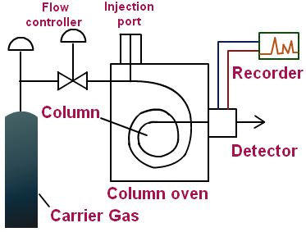
Figure 1: Schematic of a gas chromatogram

Curabitur consequat purus neque, euismod ultrices eros rhoncus vel. Etiam eget hendrerit velit. Pellentesque habitant morbi tristique senectus et netus et malesuada fames ac turpis egestas. Donec interdum arcu eget magna imperdiet, vitae porttitor turpis suscipit. Phasellus ut facilisis augue, id cursus nunc. Sed convallis sapien at auctor finibus. Curabitur lacinia massa convallis, viverra erat a, dictum nisl (Figure 2). Mauris sed ex sit amet diam aliquam aliquam in a sem. Ut cursus, nisi vehicula sollicitudin egestas, magna eros dignissim augue, sed aliquam dolor arcu at neque. Integer rutrum vitae diam nec eleifend. Phasellus ultricies tincidunt nisi, at efficitur lorem vestibulum et. Nunc vel metus condimentum, imperdiet risus at, pretium velit. Sed congue, lectus nec efficitur ultricies, lectus dui congue metus, eleifend lobortis mauris ex non erat. Sed iaculis dolor id euismod feugiat.

Aliquam eleifend lectus sapien, pulvinar sagittis tellus vestibulum sit amet. Nunc condimentum auctor metus id auctor. Nam ipsum lectus, fringilla id elementum in, gravida vitae neque. Nam quis auctor orci. Vivamus mattis velit ut velit tincidunt, at ullamcorper odio cursus. Proin at nisi orci. Aenean tincidunt dolor in ipsum rutrum finibus. Quisque malesuada nisl sit amet dolor commodo condimentum. Donec tempor nisl sed nulla molestie, eget sollicitudin magna feugiat. Nunc at blandit libero, vitae porta leo.

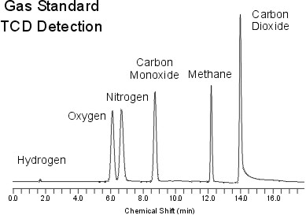
Figure 2: Example of a GC spectrum
Mass Spectrometry
Lorem ipsum dolor sit amet, consectetur adipiscing elit. Nam sit amet sollicitudin turpis. In dictum orci enim. Donec placerat sapien nec nisl pharetra, at vehicula odio efficitur. Phasellus mauris arcu, sagittis interdum lacus sed, varius fringilla nunc. Ut hendrerit tincidunt turpis ac ultrices. Nam diam ex, vulputate sit amet elit at, porta pharetra sem. Vestibulum consequat tempus velit vel scelerisque. Aenean sit amet turpis in tortor aliquam fermentum. Pellentesque pulvinar malesuada venenatis. Cras lacinia ante quis est iaculis, nec scelerisque nulla scelerisque. Duis ut odio sodales, tempor dui eu, dapibus risus (Figure 3).
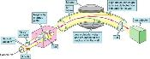
Figure 3: Schematic of a mass spectrometer

Suspendisse potenti. Donec condimentum condimentum tellus, eget euismod eros cursus eu…

- Suspendisse fermentum ut enim eu tempus. Curabitur non ullamcorper lacus, eget faucibus diam. Vestibulum mollis tempor elit a luctus.
- Mauris molestie, neque sit amet suscipit vehicula, dolor nisi mattis augue, in ullamcorper nulla lacus a ante. Aliquam cursus viverra orci, ac tempus est dapibus id.
- Nullam tempor fermentum arcu non venenatis. Nullam commodo feugiat ipsum at luctus. Sed vehicula euismod magna tempor aliquet.

Detecting steroids using GC-MS
Suspendisse potenti. Donec condimentum condimentum tellus, eget euismod eros cursus eu. Suspendisse fermentum ut enim eu tempus. Curabitur non ullamcorper lacus, eget faucibus diam. Vestibulum mollis tempor elit a luctus. Mauris molestie, neque sit amet suscipit vehicula, dolor nisi mattis augue, in ullamcorper nulla lacus a ante. Aliquam cursus viverra orci, ac tempus est dapibus id. Nullam tempor fermentum arcu non venenatis. Nullam commodo feugiat ipsum at luctus. Sed vehicula euismod magna tempor aliquet. Proin vel volutpat quam. Nam dapibus pellentesque arcu, et tempor justo ullamcorper nec (see Figure 4).

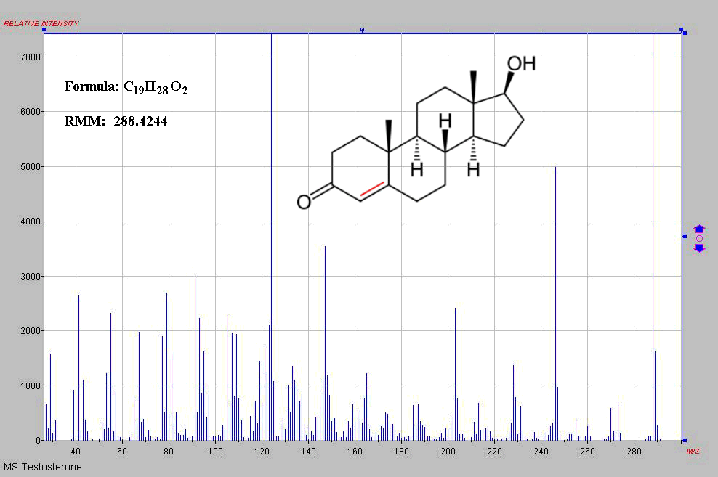
Figure 4: Chemical structure and mass spectrum of testosterone

Referencing:
It is essential in academic writing that you show the source of all information that you did not come up with yourself. In this assignment you will need to show where all of your information has come from using in-text citations and a formatted bibliography.

Formatted bibliography:
The formatted bibliography goes at the end of your document. In academic works you cannot just include a list of URLs. Bibliographies should include information such as the author, date published, title and (for online sources) the date that you accessed or viewed the page. There are different systems used to format references such as APA or Harvard. In this assignment we will use the APA referencing system.
Websites such as www.citethisforme.com can be used to generate a formatted bibliography. The following screenshots show how to add a reference to www.citethisforme.com
Step 1: Go to website. Click “Citation style” in top bar and change it to APA (6th edition)
Step 2: Click add “Book” or “Website” (depending on what source you’d like to add)
Click the “Add manually” button.
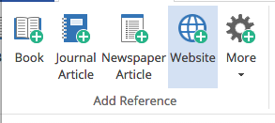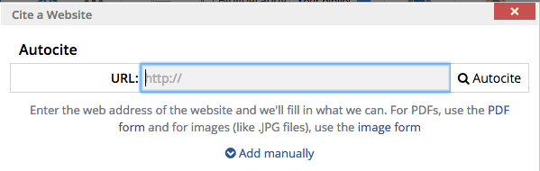

Step 3: Add details from the website (e.g. author name, page title, URL). Then click add reference.
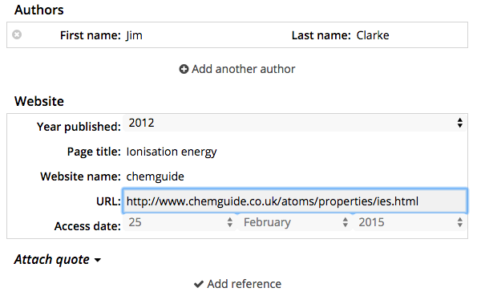
Step 4: Screen now shows your citation. The “Bibliography” field is the formatted bibliography details for the source you just added.
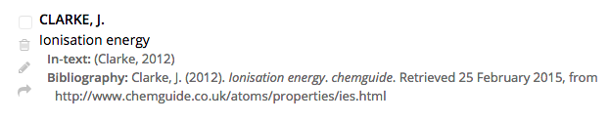
Step 5: If you have added all of your sources then you can click the “Download bibliography” button to generate a bibliography using all of those sources. Alternatively, copy and paste all of the formatted bibliography details into your assignment document.
Note: Bibliographies are sorted in alphabetical order.
In-text citations:
In-text citations occur in the body of your writing. They show that the information in a sentence or group of sentences have come from one particular source. An example of in-text citations in a chemistry research project are shown below:

Introduction
Organic compounds in sediments offer a wealth of information about past environments. Certain biochemicals from living organisms can be selectively preserved and incorporated into the sedimentary record, eventually leading to the formation of biomarkers – chemical fossils that can be linked to their precursor lipids and organisms (Peters et al., 2005). As flora distribution is controlled by climate, biomarkers related to higher plants can be used help reconstruct paleoenvironments (Orem et al., 1997; Grice et al., 2005). Such reconstructions are limited, however, by a lack of knowledge of paleochemotaxonomy (Hautevelle et al., 2006). Insights into the taxonomic distribution of higher plant biomarkers will significantly aid in the interpretation of sedimentary records.
Adapted from ‘Pyrolytic and isotopic methods for the characterisation of biomarkers related to native Australian plants” (McKenna, 2009)
In this paragraph, the following ideas came from sources other than the author:
- The idea that biochemical can be preserved and changed into biomarkers
- The idea that biomarkers can be used to reconstruct paleoenvironments
- The idea that it is difficult to reconstruct paleoenvironments because we don’t know much about paleochemotaxonomy
The original author is shown using brackets containing the name of the author and the year the work was published. (Note: In this example the phrase “et al.” was used to mean “and others” because these works had multiple authors)
The brackets with the author and year match up to references that appear in the bibliography.

References

Grice, K., Backhouse, J., Alexander, R., Marshall, N., Logan, G.A., (2005) Correlating terrestrial signatures from biomarker distributions, [delta]13C, and palynology in fluvio-deltaic deposits from NW Australia (Triassic-Jurassic). Organic Geochemistry, 36(10), 1347-1358.

Hautevelle, Y., Michels, R., Lannuzel, F., Malartre, F., Trouiller, A., (2006) Confined pyrolysis of extant land plants: A contribution to palaeochemotaxonomy. Organic Geochemistry, 37(11), 1546-1561.

Orem, W.H., Colman, S.M., Lerch, H.E., (1997) Lignin phenols in sediments of Lake Baikal, Siberia: application to paleoenvironmental studies. Organic Geochemistry, 27(3-4), 153-172.

Peters, K.E., Walters, C.C., Moldowan, J.M., (2005) The Biomarker Guide. Cambridge University Press, Cambridge, UK.

IN YOUR ASSIGNMENT:
- Every piece of information that is not ‘common knowledge’ should have an in-text reference either for that sentence or for that paragraph.
- There needs to be a bibliography reference for every in-text reference (and vice versa)
- You cannot cite “The teacher” for an in-text reference. If I told you something in class, you need to find a published source which says the same thing.

Chemistry Unit 1 & 2 – Assignment #1 Marking Key Name: _____________________
CONTENT
Aspect | 0 marks | 2 marks | 4 marks | 6 marks
How the instrument works | Describes a general principle of how machine works but lacks many details | A diagram shows the parts of the instrument and some information is given about what the different parts of the instrument do. | A diagram shows the function of the machine and information is given about the role of different parts of the instrument. Some description of chemical principles underpinning how the machine works using appropriate terminology (e.g. emission and absorption for AAS, elution and retention for GC-MS) | The function of each part is clearly described with details that show a level of research (i.e. not just paraphrased from textbook). Gives elaborate background into the chemical principles relevant to the analytical method (e.g. energy levels and absorption spectra for AAS, chromatographic principles for GC, etc.)
How data from the instrument is used | No explanation of how the output from the machine is used | Describes the type of output generated by the instrument. | Describes how the output of the instrument can be used to analyse, identify or detect substances and includes an appropriate image/table. | Explains how the results are used to analyse, identify or detect substances. Includes example AAS data or GC-MS data and demonstrates how this would be used for the particular application described.
Description of application | Lists the chosen application | Explains the importance of the chosen application. | Explains the importance of the chosen application and describes the chemistry of the substances which need to be analysed.

COMMUNICATING THROUGH ACADEMIC WRITING:
Aspect | 0 marks | 1 mark | 2 marks
References list | - | Most references are correctly formatted using APA. Occasional minor problems. | All references correctly formatted using APA. No errors in referencing details.
In-text citations | - | Some attempt to use in-text citations but some parts are missing citations. | All information that is not common knowledge is attributed using a form of in-text citations.  PART 2: ASSIGNMENT  Content = ____ / 16  Communication = ____ / 8  Total = ____ / 24  This will be combined with your mark in the validation test to achieve a total score /100.
Sources | - | At least three sources are used including at least one text source.
Conventions for figures and tables | - | Includes at least one figure or table. All figures and tables are labelled, include captions and sources, and a referenced in the main text.
Headings | - | Divides report into logical sections using headings.
Writing | - | High quality presentation of writing with minimal spelling or grammar errors

